**CAPSTONE PROJECT MID-TERM SUBMISSION**



Name- Vicky kumar

Roll- 21F1005331

Email- 21f1005331@ds.study.iitm.ac.in

| **Sr No** | **Topic** | **Page No** |
| --- | --- | --- |
| 1 | Executive Summary | 2 |
| 2 | Proof of originality of the Data | 2 |
| 3 | Metadata and Descriptive Statistics | 4 |
| 4 | Analysis process | 6 |
| 5 | Result and finding | 7 |

**ICE CREAM ON A STICK**

1. **Executive Summary**

Ice cream is a sweetened frozen food typically eaten as a snack or dessert. Ice cream has an increasing demand in the present era, Ice cream uses regular basis as a food supplement hence there is a great demand for Ice cream. Ice cream is uniquely shaped and can be produced in a wide variety of colors, flavors, and coating. Ice cream is popular and commonly available in the forms of cups, bars, and candies.

There are millions of street vendors in India and Sunil Yadav is also one of them. He is selling ice cream for 5 years and maintains their sales data in many diaries. This mid-term Report includes proof of originality of Data, Metadata and Descriptive Statistics, Analysis process, Result, and Findings.

In this report, pictures and videos refers to talking to a local street vendor about their business. In metadata and Descriptive Statistics Bar graph, the line chart are used to show revenue, gross profit, etc. In the analysis process, we entered all the input data into Excel, and then data has to categorize into some columns as different flavors, selling price, cost price, etc. And lastly, there is an outcome from this analysis in the Result and findings.

1. **Proof of Originality of data**

Video – In the video, a small interaction between me and the ice cream vendor, Sunil Yadav Ji.

I questioned him about how the sales of ice cream are going and what problems he faces in daily life, from where he bought the ice cream, what are his opinion on the digital transaction and whether they want to expand their business.

(The duration of the video is 4.36 minutes.)

Link - <https://drive.google.com/file/d/1F7DazB3tWr1jfTSELWEBV1HbblP0Xcfj/view?usp=share_link>

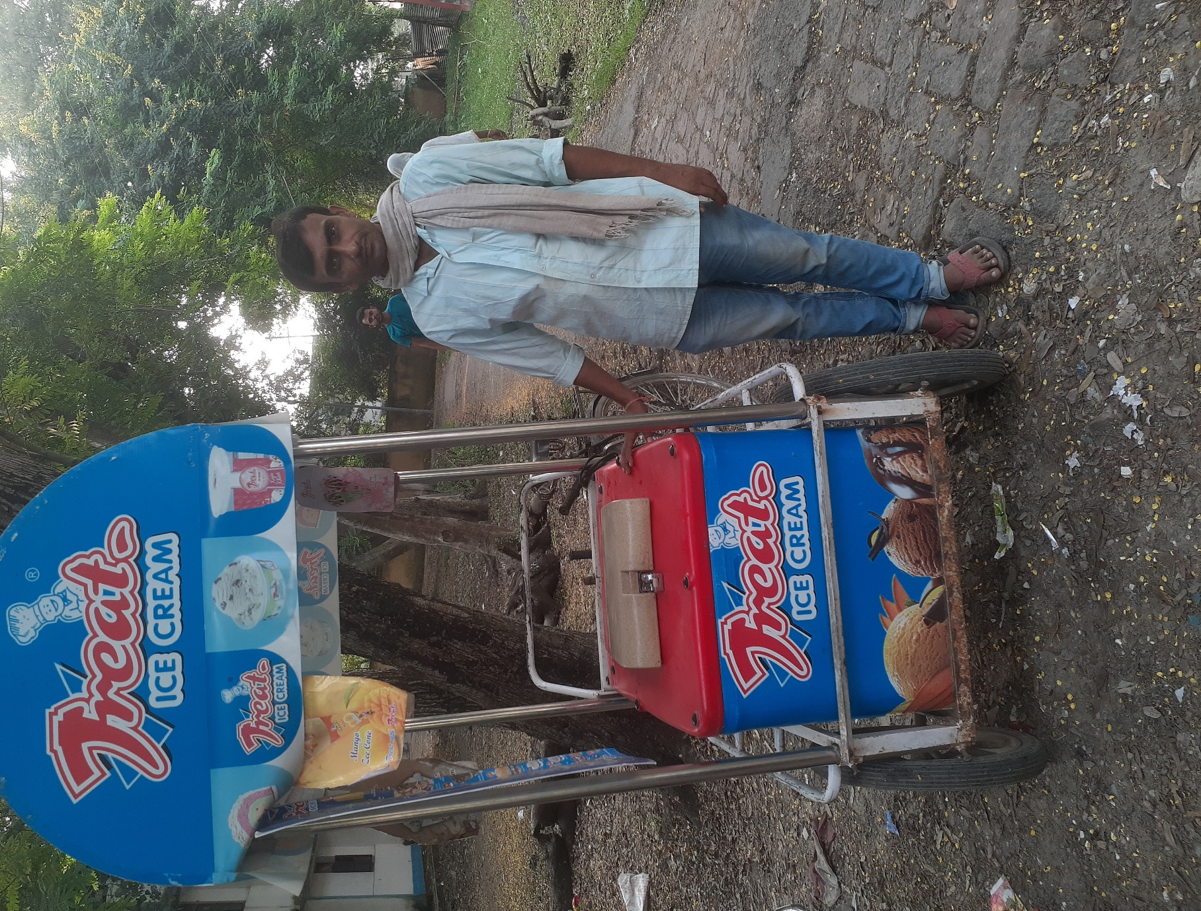



Data collected –

The data provided by the owner in an unstructured form and after sorting, removed unwanted columns, etc. Here are the insightful conclusion from the raw data.

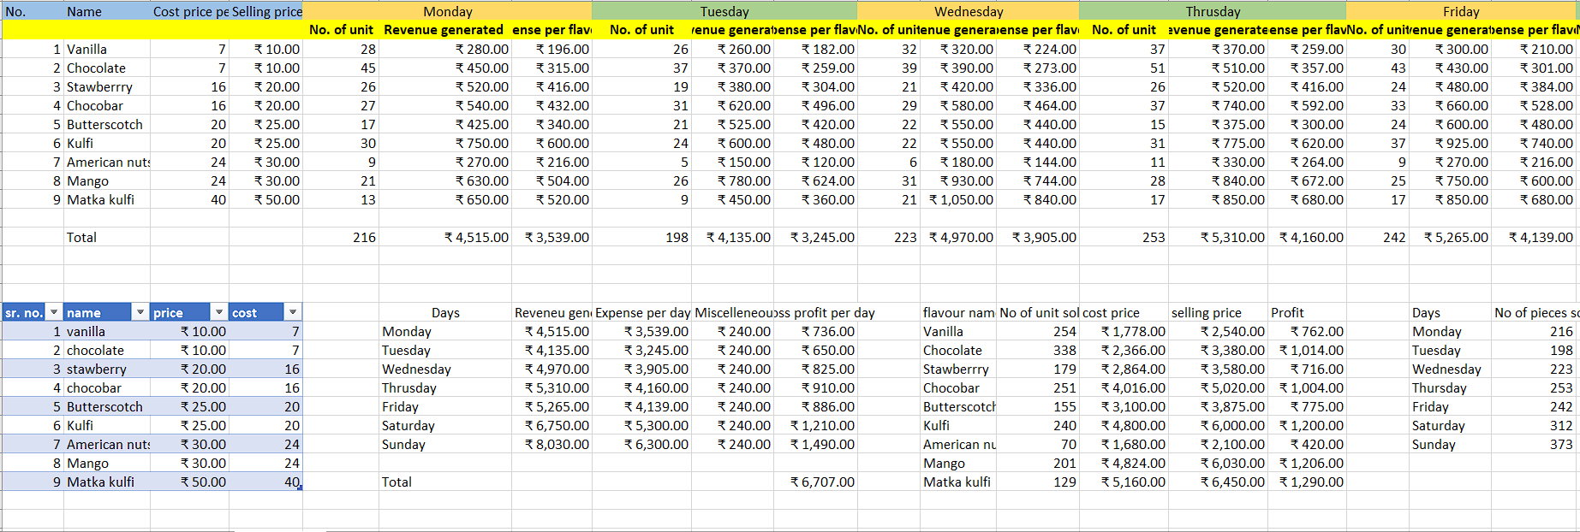

1. **Metadata and Descriptive Statistics**

The data was collected for 4 weeks starting from 19 February 2023 to 12 March 2023. The original sales data was kept in diaries and I visited their location 2 to 3 days each week throughout this time period.

Figure 1. a depicts the number of ice cream sold in week 1 for each flavor.

Fig 1.a

Figure 1. b depicts the number of ice cream sold in week 2 for each flavor.

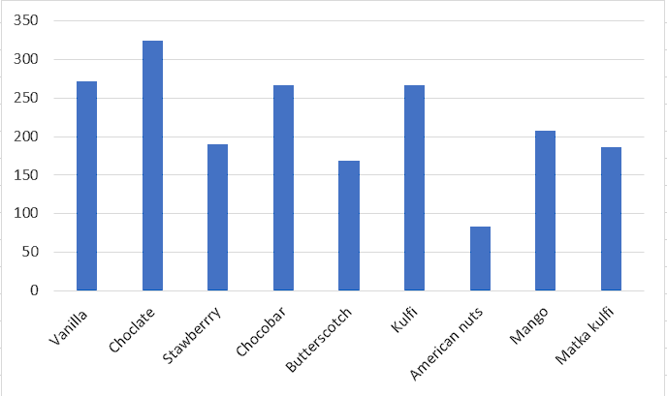

Fig 1.b

Figure 1. c depicts the number of ice cream sold in week 3 for each flavor.

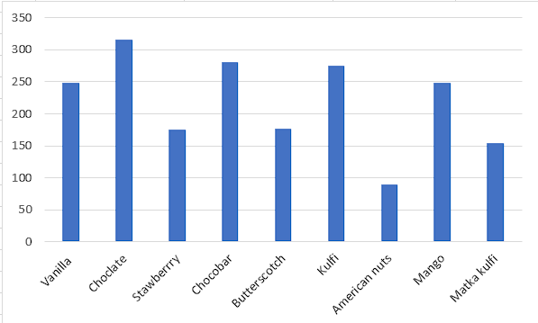

Fig 1.c

Figure 1. d depicts the number of ice cream sold in week 4 for each flavor.

Fig 1.d

1. **Analysis Process**

Excel can be used to visualize the data more accurately with the help of searching, sorting, etc. The tool used for the analysis of sales data is Ms excel. The collected sales data is entered into Excel, and then we clean the data.

The bar chart, Pareto chart, and line chart are used to show the revenue generated, expenses, gross profit, number of pieces sold in a day, and number of ice cream sold in a week for each flavor.

The following are the steps that were taken for the analysis:

* The given raw data was entered into Excel then the data were search, sorting, replace etc.
* The created column named flavors name, cost price, selling price, and days. The day’s column has been split into three different columns named the number of pieces sold, revenue generated, and expenses.
* By making a line chart, we see that the sales on weekends are comparatively higher than on weekdays.

1. **Result and Finding**

From the above graph and chart, we saw that the chocolate and chocobar flavors are the most popular among consumers. The American nut flavor is less popular than other flavors.

Revenue generated-

Based on the revenue analysis graph, we can deduce that weekends provide the majority of revenue, while weekdays generated less revenue. In the graph we can clearly see that revenue is increasing from Wednesday to Sunday.

This bar graph analysis is for week 1.

Gross profit-

From below Pareto chart, we can conclude that Sunday and Saturday (weekends) are the most profitable days, while Tuesday is the least profitable days.

